**Goal**

The goal of this work is to introduce thermography (terminal imaging) of plants.

**Setup**

A FLIR E5 thermal camera is used to image 18 soybean plants in a greenhouse. The plants are then moved to an air-conditioned headhouse (~72F) and imaged three more times to monitor cooling. All timepoints are about ten minutes apart.

**Analysis assumptions**

1) 18 plants split between two treatments: Treatment 1 = sunlight and artificial lights, and Treatment 2 = sunlight without artificial lights. 2) Plants are measured in the same order during each of four timepoints.

**Expectation**

The plants will be warmest in the greenhouse and cool in the headhouse. All plants receive similar amounts of water and little difference is expected between the treatments. No difference is expected between the plants within a treatment during an imaging period. The measured rate of cooling in the headhouse will provide future protocol recommendations.

**Background**

The FLIR E5 camera is a handheld thermography camera for inspections of machine and buildings. The camera creates superimposed color and thermal images. The resolution of the thermal camera is 120x90 with an accuracy of “±2°C (±3.6°F) or ±2% of reading, for ambient temperature 10°C to 35°C (+50°F to 95°F) and object temperature above +0°C (+32°F)[1].” The accuracy appears to be intentionally degraded by the manufacturer[2] instead of a sensor limitation.

**Procedure**

Each image from the camera contains a color image, a thermal image, and metadata. For each image, the terminal image is separated to create a mask. (The color image is poorly registered with the thermal image and could not be used for segmentation.) Clearly defined leaves are included in the mask while stems and small or distant leaves are generally not. The mask is eroded to remove edge pixels that likely have mixed measurements of plant and soil. The thermal image is converted to a matrix of temperature readings and the mask used to isolate the roughly 1,000 temperature measurements for each plant.

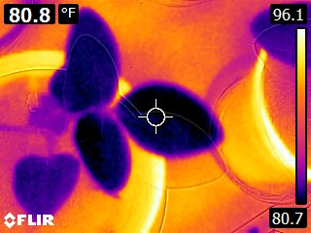 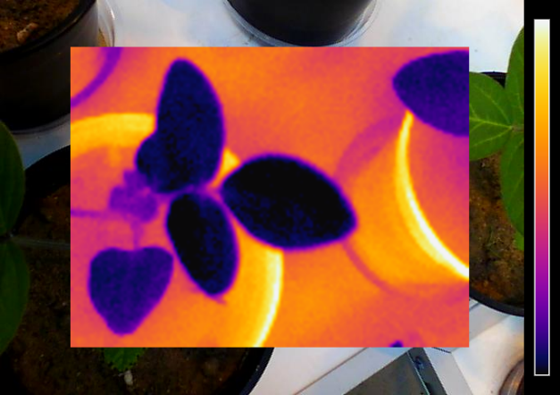

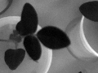 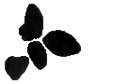

**Analysis**

The plants were first measured in the greenhouse then moved to the headhouse where their cooling was monitored. The time points are called A-D (A=greenhouse; B-D=headhouse) and treatments are called 1-2 (1=natural plus artificial lights; 2=natural light only.) The bar graphs show the median of the group’s median plant surface temperature. Plants originally under artificial lights where hotter, including after moving to the headhouse where they remained hotter.

Beyond plants being hotter in the greenhouse and under artificial lights (an effect that’s retained after being moved to the headhouse), there’s little trend seen across the timepoints suggesting that the plants cool quickly within the first ten minutes of entering the headhouse. Is the temperature dip in D1 the result of the HVAC system?

Additional information is available in the temperature distributions of each measurement. Below are three thermal images (rows) that look similar (right column). However, the histogram of leaf temperature (left column) has a more distinct signature than the median temperature value.

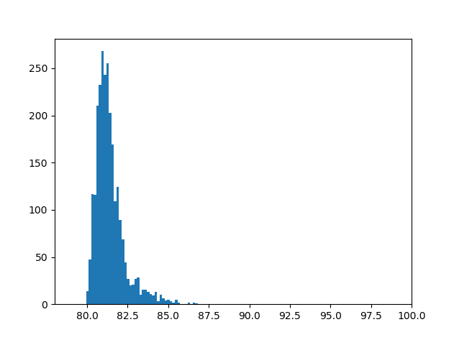 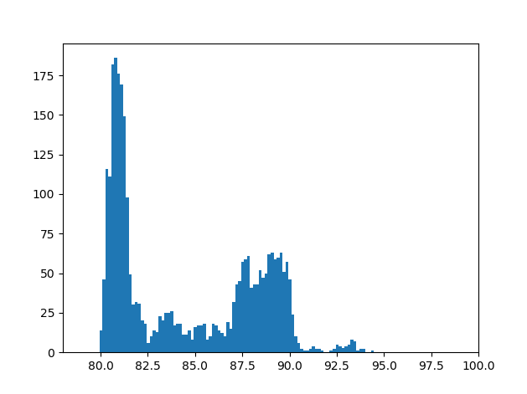 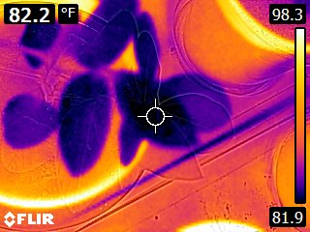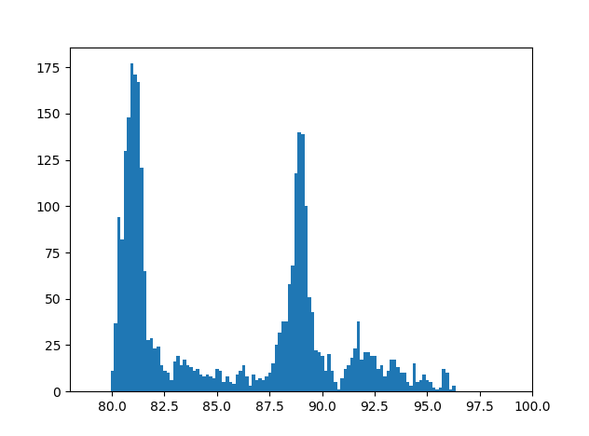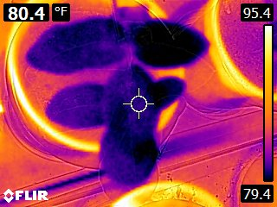

To use the additional information, histograms of masked thermal images with the same 128 bins were created across all groups and treatments. All pairs (18 plants x 4 time points) of histograms were compared using the earth mover distance (EMD) metric to generate a 72x72 matrix summarizing distance between all pairs of histograms. Dark colors represent higher similarity than bright colors. Timepoint A (greenhouse) is the dark upper-left square and the three headhouse timepoints are the dark lower-right larger section of the graph. Between the greenhouse and headhouse the greatest differences are seen. Difference between treatment can also be seen, such as in timepoint C.

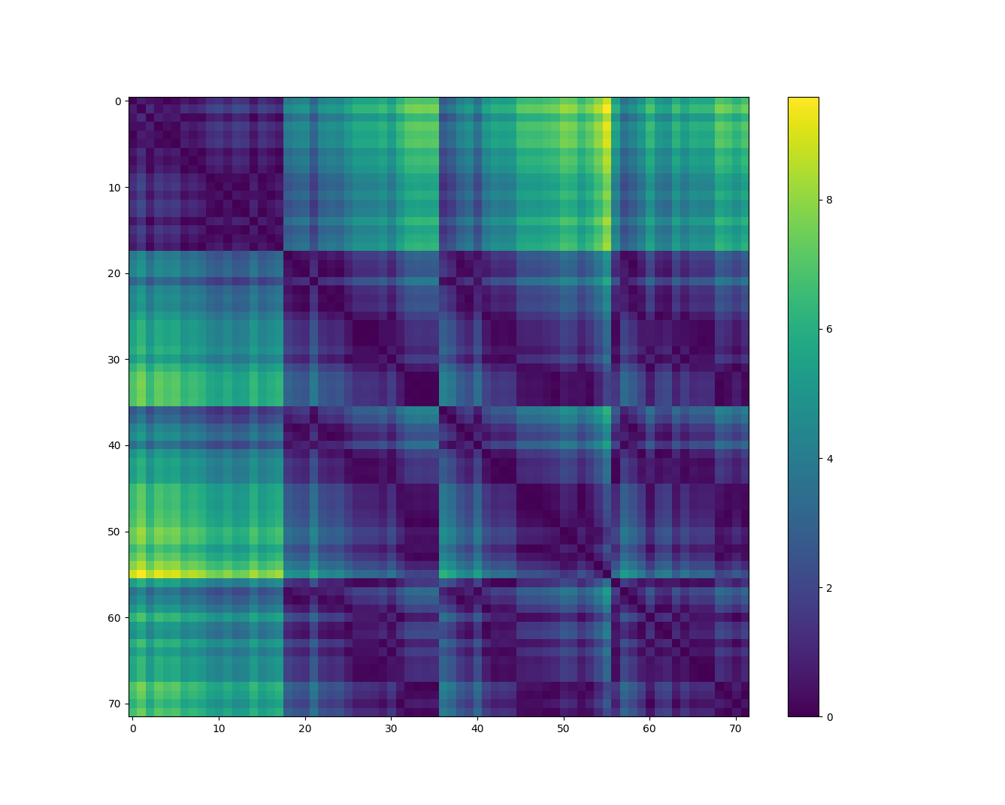

**Conclusion**

The plants used in this experiment where ones available and all measurements taken with a handheld camera. A water gradient experiment may be more interesting, where differences in leaf transpiration is expected to cause temperature differences. Differences between the greenhouse and headhouse where seen. More surprisingly, the effect of the heat from artificial light (the treatment) lingered. The expectation was after 30 minutes in the headhouse all plants would be a similar temperature eliminating the treatment effect. If repeated, the headhouse HVAC should be temporarily disabled to eliminate room inconsistencies as an explanation. Also, soil temperatures should be recorded in case heat radiated from the soil is influencing the plant measurements. Most of the cooling occurred in less than ten minutes after being moved to the headhouse, limiting time available for thermography. Thermography may need to be limited to the greenhouse. The sensitivity of the experiment is limited by the camera accuracy. Stacking images to improve signal-to-noise (SNR) may help, requiring a rig to hold the camera rigidly while multiple images are collected.

1. from the FLIR E5 specifications
2. <https://www.eevblog.com/forum/thermal-imaging/flir-e4-thermal-imaging-camera-teardown/msg342315/#msg342315>